**Assignment 6 – Web page – Flow Diagram : Raga Ranjini(19001198)**

app.module.ts

main.ts

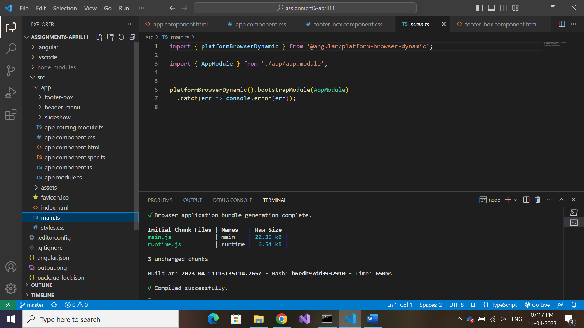 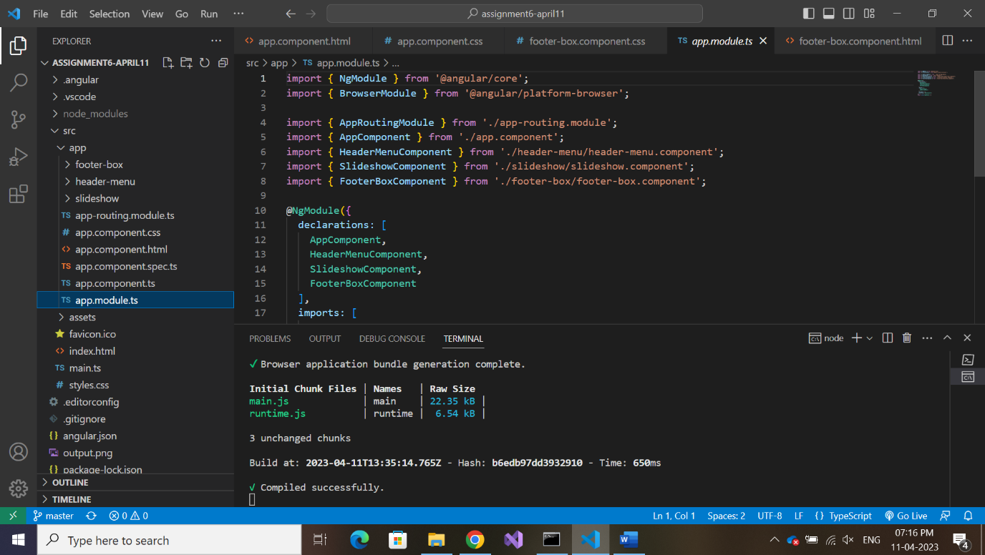

On creation of components, the created

Components get declared here.

**On successful compilation , index.html gets served to web server.**

<app-root></app-root>

app.component.html

index.html

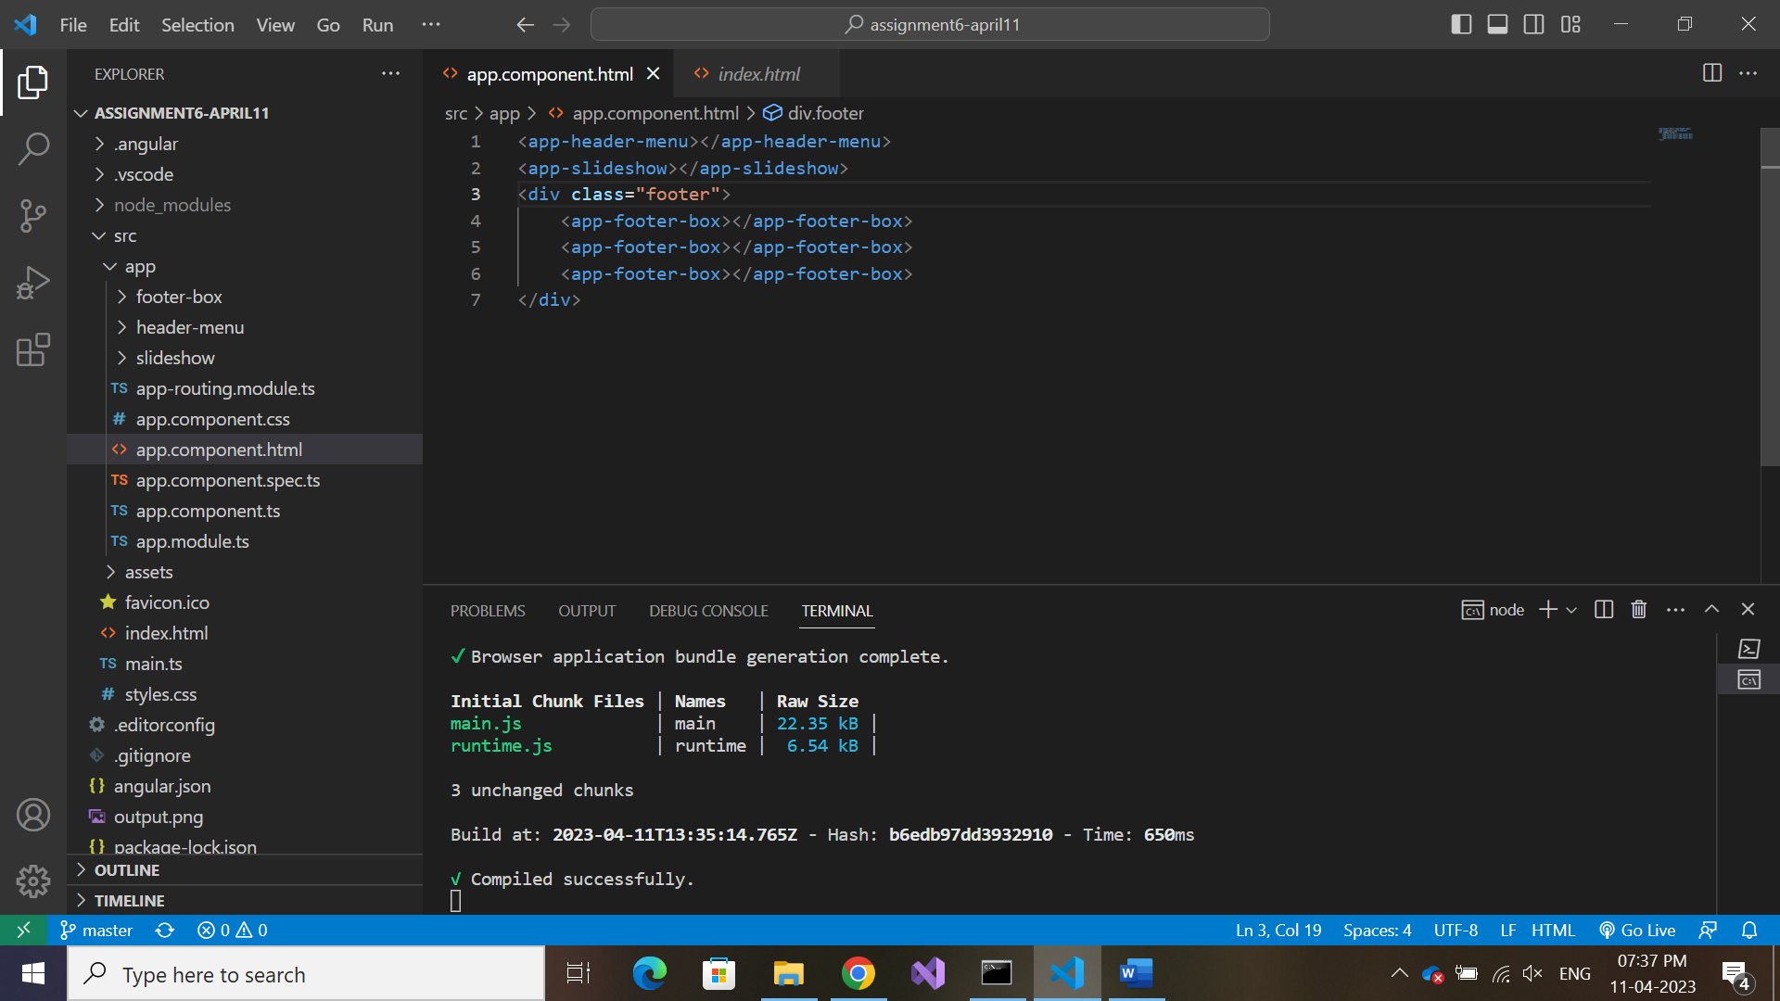

app.component.html

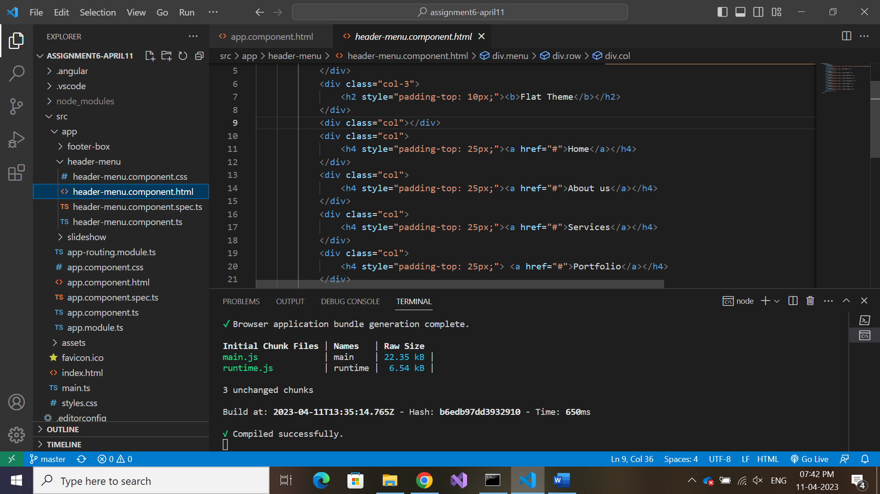

3

2

1

